**Assignment 3**

**D. Harshith Reddy**

**CB.EN.U4CSE20215**

In 2010, ACLU of Northern California presented a report on jury selection in Alameda County, California. The report concluded that certain ethnic groups are underrepresented among jury panellists in Alameda County, and suggested some reforms of the process by which eligible jurors are assigned to panels.

Ethnicity tells us about the ethnic categories of people in Alameda, Eligible tells us about the percentage of people eligible grouped by ethnicity and Panel tells us about the proportion of people currently chosen for the panel.

**Null Hypothesis (h0): Panel members were selected at random from the population of eligible.**

**Alternate Hypothesis (h1): Panel members were not selected at random.**

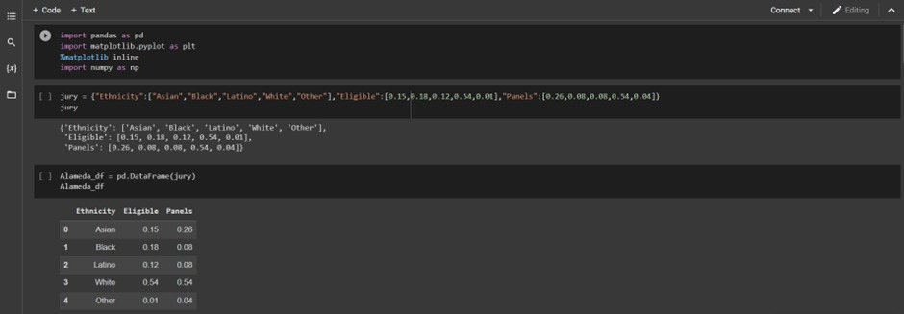

Through this, we can clearly see that there has been a bias in choosing panel members.

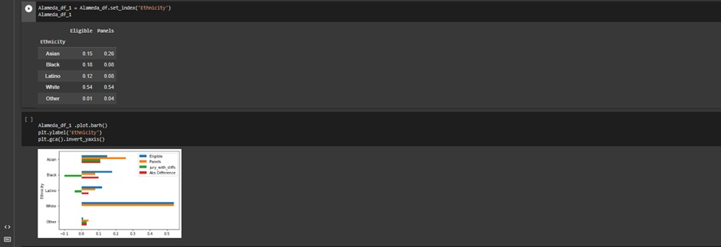

For finding the bias we Subtract the Panel from the eligible, if we get a +ve value then the bias is such that more people than eligible are selected in the panel if a -ve value then the bias is such that fewer people than eligible are selected in the panel and if it is Zero all eligible are selected for the panel.

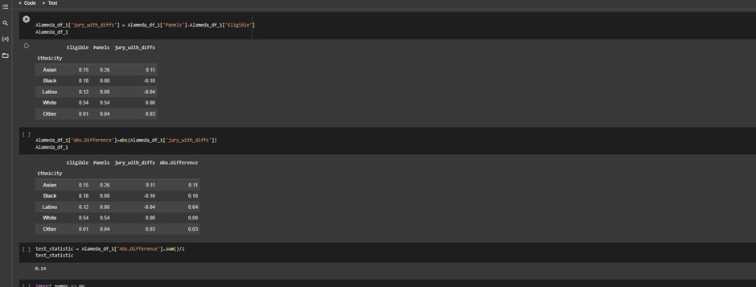

total variation distance is 0.14

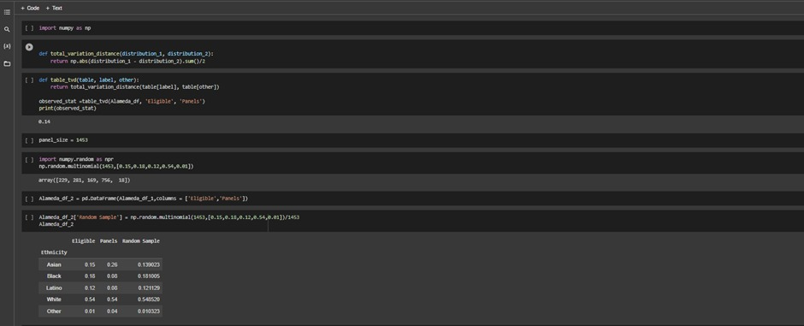

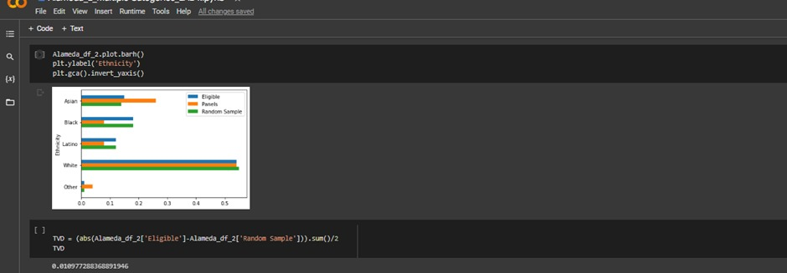

The overall distance between a random sample size of 1453 and the population of potential jurors varies for each row in df_4.

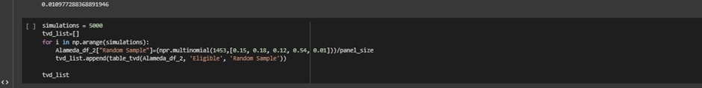

The overall distance between a random sample size of 1453 and the population of potential jurors varies for each row in df_4.

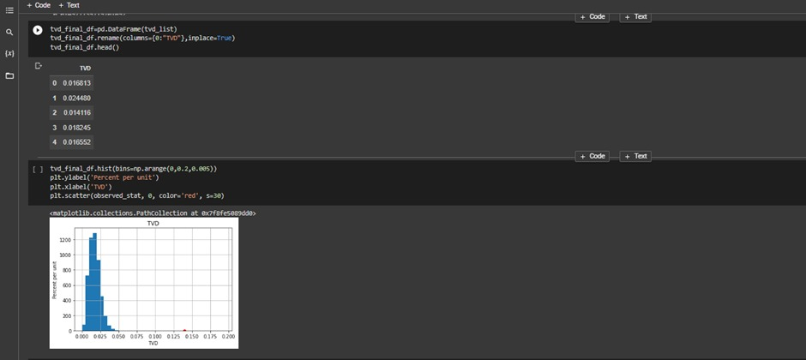

By empirical histogram presented above, Drawing 1453 jurors at random from a pool of eligible candidates results in a distribution that does not deviate from the distribution of eligible jurors by more than 0.059085, according to the empirical histogram presented above of the simulated distances. The red dot in the histogram above indicates that the total variation gap between the panels and the eligible population (0.14) is very large. The panel data does not match the statistic's projected values according to the model of random selection. So, the null hypothesis is rejected